**Game 1 Lab Manual: What’s in an Image?**

**Why?**

Understanding the components of an image is the basis to understanding an MR image and altering it to your specifications. Components like **voxels**, **field-of-view**, and **matrix size** allow the user to manipulate the **resolution** and viewing range to achieve the specific image quality.

**Materials**

* Star phantom
* Two dots phantom

**Background:**

1. Key Terms
2. Pixels/Voxels
3. Resolution
4. Matrix size
5. Field-of-View (FOV)
6. Windowing
7. Basics

There are two main types of digital images: monochrome and color. Color images can be represented with three components: Red, Green, and Blue (RGB). It is the layering of these three colors that make up the final image. Monochrome images are made up of different gray levels. MR images are examples of monochrome images: each voxel has one number, called the image magnitude or intensity, that indicates its brightness.

1. Explanations
2. **Pixels/Voxels**: It is a metric defining **each unit in a picture/scan**. A **pixel** defines space in a scan with **two dimensions**, while the **voxel** defines a space in **three dimensions**. MR images are made up of voxels as they always have a third dimension or thickness.

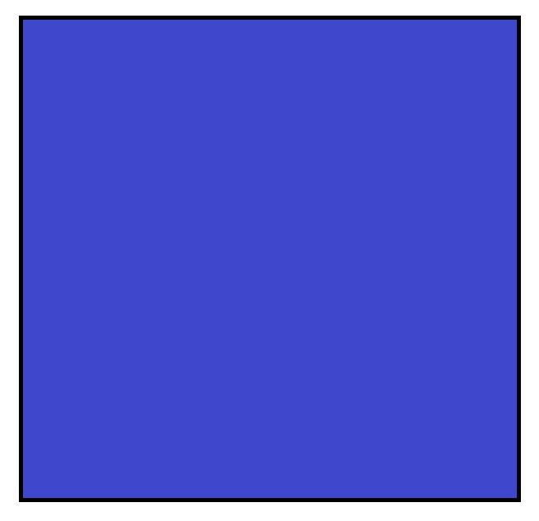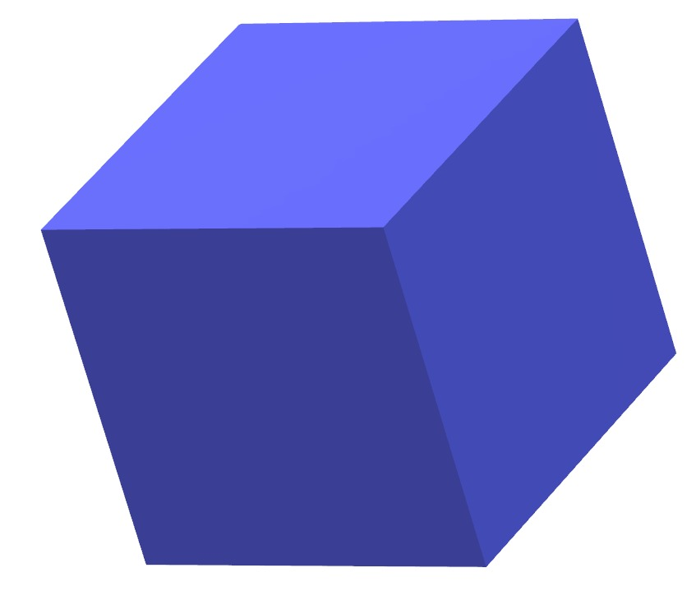

As seen in the above image, the pixel (left image) is two-dimensional and exists on the x-y plane while the voxel (right image) is three-dimensional and exists on the x, y, and z space. The pixel only has a length and a width while the voxel has a depth as well.

1. **Resolution** refers to how sharp an image is and It is related to the size of the individual pixel (2D) or voxel (3D). The smaller the pixel or voxel the greater the resolution. Voxels segment continuous space into discrete units. The signal in each voxel is an **average of all the sub-signals within it**. The smaller you make the voxels, the more closely spaced details you see because they tend to be assigned to different voxels. You **cannot see the details** when using very large voxels because the spatial details are averaged out and any locational information at smaller scales than the voxel is lost.

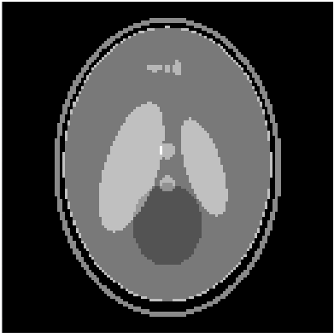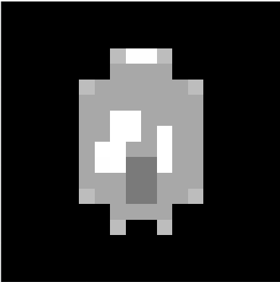

The above image contains two pictures: one with high resolution (left) and the other with low resolution (right). The higher resolution image expresses more details.

1. **Matrix size (N):** Matrix size is an integer equal to the number of voxels in each dimension. For example, an MR image can have a matrix size of 512 x 256, meaning that one side is divided into 512 parts and the other is divided into 256 parts. The image would have a total of 512 x 256 = 131072 voxels. **Small and a lot of voxels** mean the information is going to be better localized leading to **more of the details being pronounced** (remember that the more information gets averaged in each pixel, the less pronounced it will be). This is like having a high-megapixel camera.

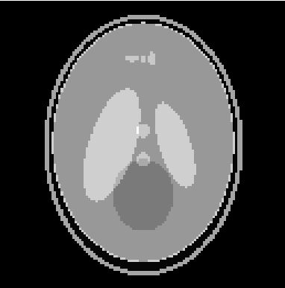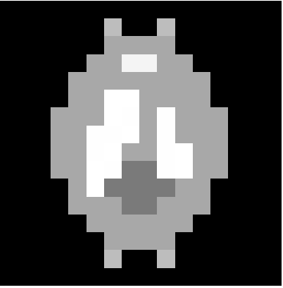

The image above has two pictures: one with many small pixels, and the other with fewer large pixels. As seen, the left picture has a higher resolution than the right one.

1. **Field-of-View(FOV):** As you zoom in on a camera, a specific part of the image is seen while the rest is discarded. Field-of-view (FOV) is usually given in millimeters in MRI and refers to how much physical distance is covered between the left and right (or top and bottom) sides of the rectangular image. When matrix size is kept the same but FOV is increased, each pixel covers a larger distance and this **lowers the image resolution**.

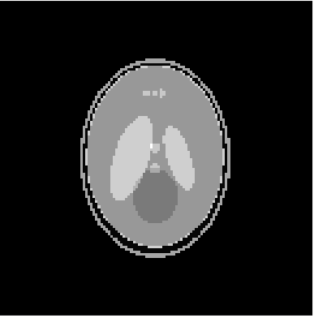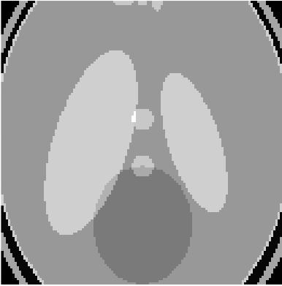

Two simulated images of the same brain-like object but different FOVs are shown above. The image with the higher FOV (left) covers the entire object imaged. The image with the small FOV (right) is focused on one part of the image while the rest is discarded.

1. **The relationship between FOV, Voxel Size, and Matrix Size**: Since the following three variables are dependent on each other, they cannot all be freely set. This is similar to a simple y=mx+z function. You can set two of the three variables freely and solve for the other but you cannot set the value for all three variables and have the equation be true everytime. Similar to that, we can change two of either FOV, Voxel size, or Matrix Size and solve for the other variable. The equation relating all three variables is:

*Field-of-View = Matrix Size x Voxel Size.*

1. **Windowing**: Windowing affects the image contrast by filtering out certain signal intensities. When you window an MRI image, you are selecting which signal intensities you want to view and which you want to ignore. The window is defined by two values: the “min intensity” and the “max intensity”. When an image is windowed, all values <= min level are set to zero while all values >= max level are set to 1. The values in between min level and max level are rescaled so they range from 0 to 1. The width of the window is defined as:

*window width = max level - min level*

While the “level” of the window is defined as their midpoint:

*level = 0.5 x (max level + min level)*

The wider your window, the more intensity values are present and the more contrast you can cover, but smaller contrasts are less apparent. The opposite is true for when the window gets narrower as fewer intensity values will be selected and tiny intensity differences will appear more dramatic.

1. **Voxel size vs. true resolution**

Voxel size is often representative of resolution, but not always. One definition of true spatial resolution is how close together (say, in millimeters) two thin lines can get before they can no longer be told apart. In fact, with a technique called zero-filling, we can generate images of very large matrix sizes from images of smaller matrix sizes. In this process, the voxel size is reduced, but true resolution is not improved because the new image contains no more information than the old, pixelated image. One example is shown below:

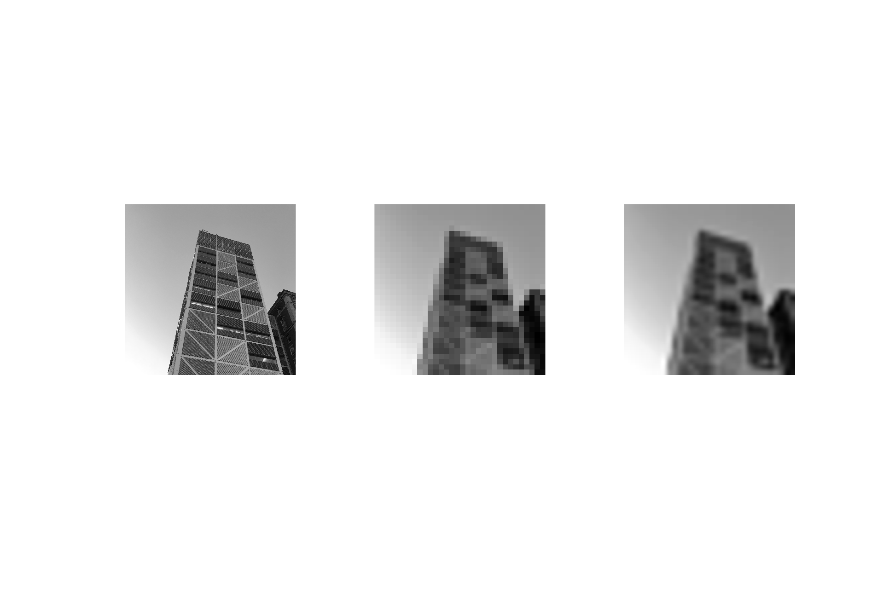

1024 x 1024 Resized 32 x 32 Zero-filled back to 1024

When the 32 x 32 image is zero-filled back to 1024 x 1024, the details are still lost. The information we missed out on when acquiring fewer pixels from the beginning are NOT recovered by the zero-filling. It merely “smoothes out the pixels” but does not improve true resolution at all.

1. Lab Procedure

Image the star tube with 3 Field-of-View settings: largest FOV(pick the largest value of those available), smallest FOV(pick the smallest value of those available), and perfect FOV (re-run the experiment until you find the perfect amount). Fill out the below table.

|  | Biggest FOV | Smallest FOV | Perfect FOV |
| --- | --- | --- | --- |
| Value |  |  |  |
| Impact on Resolution |  |  |  |

* + 1. Sketch and describe what you see for biggest, smallest, and perfect FOV
       1. Big:
       2. Perfect:
       3. Small:
    2. Keeping the perfect FOV, change the matrix size and describe the images. Which matrix size produced the highest resolution?

|  | Matrix size = 16 | Matrix size = 32 | Matrix size = 128 |
| --- | --- | --- | --- |
| Resolution |  |  |  |
| Image features |  |  |  |

Image the star tube a few different matrix sizes and zero-filled sizes; fill out the below table with your findings.

| Voxel size (mm) | Matrix Size | Zero-filled to | Observations |
| --- | --- | --- | --- |
|  |  |  |  |
|  |  |  |  |
|  |  |  |  |
|  |  |  |  |
|  |  |  |  |

* + 1. Describe what you see as you change each of the following:
       1. Matrix size:
       2. Voxel Size:
       3. Zero-filled size:
    2. How would actual resolution be affected with the following:
       1. Increasing matrix Size while keeping FOV the same:
       2. Decreasing voxel size while keeping matrix size the same:
       3. Keeping FOV and matrix size and increasing zero-filled size:

Adjust the windows on the image display to explore its effects. Fill out the table with your findings about intensity values. The bullet points below suggest some specific combinations to try:

* Min = 0, max = 1
* Min = max = 0.5
* A high minimum (0.31-0.5) with low maximum (0.51-0.8)
* A low minimum (0.1 - 0.3) with a low maximum (0.51-0.8)
* A high minimum (0.31-0.5) with a high maximum (0.81-1)
* A narrow window
* A wide window

| Experiment | Min intensity (0-1) | Max intensity  (0-1) | What can you see? | What is missing? |
| --- | --- | --- | --- | --- |
| 1 |  |  |  |  |
| 2 |  |  |  |  |
| 3 |  |  |  |  |
| 4 |  |  |  |  |
| 5 |  |  |  |  |
| 6 |  |  |  |  |
| 7 |  |  |  |  |

Take-Aways:

1. What happened when the min value was decreased while the max value stayed the same?
   1. Ans.
2. What happened when the max value was increased while the min value stayed the same?
   1. Ans.
3. What happened when the width of the window was increased?
   1. Ans.
4. Questions
   1. What combination of matrix size and FOV leads to the highest resolution?
      1. Matrix size = 16, FOV = .16 mm
      2. Matrix Size = 18, FOV = .36 cm
      3. Matrix Size = 128, FOV = .25 cm
   2. Why does acquiring smaller pixels lead to better resolution?
      1. More pixels means a larger range of gray values are possible
      2. A small pixel contains more information than a large pixel
      3. Pixel amount and size have no effect on resolution
      4. Each pixel represents a smaller amount of space
   3. What min/max window settings would allow the most visual contrast to show up between the two circles (numbers indicate gray level)?

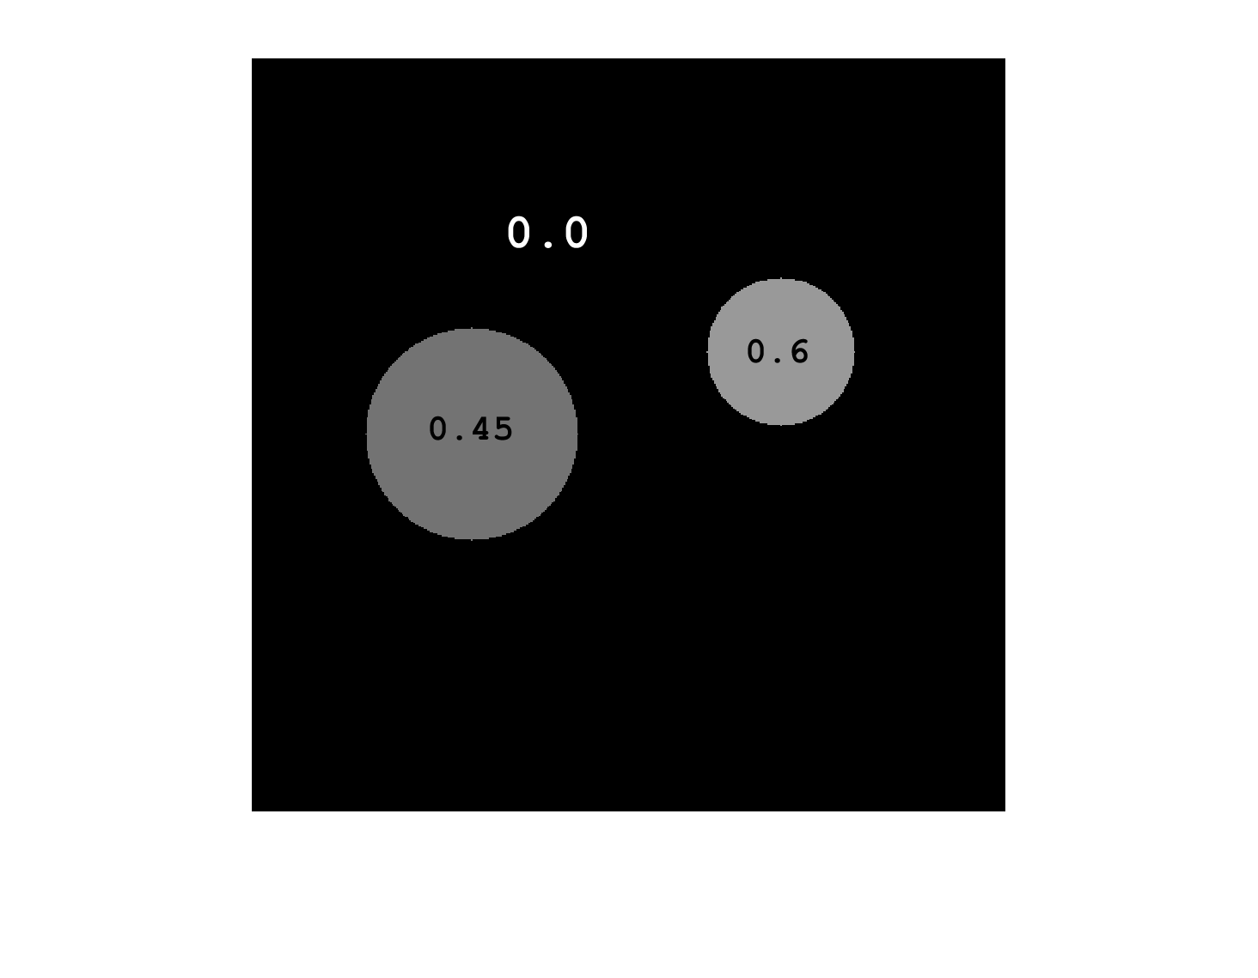

* + 1. Min: 0.01 Max: 0.99
    2. Min: 0.2 Max 0.4
    3. Min: 0.5 Max: 0.5
    4. Min: 0.3 Max: 0.7
  1. Look at the following images and answer the questions:
     1. Which image has the highest Resolution?

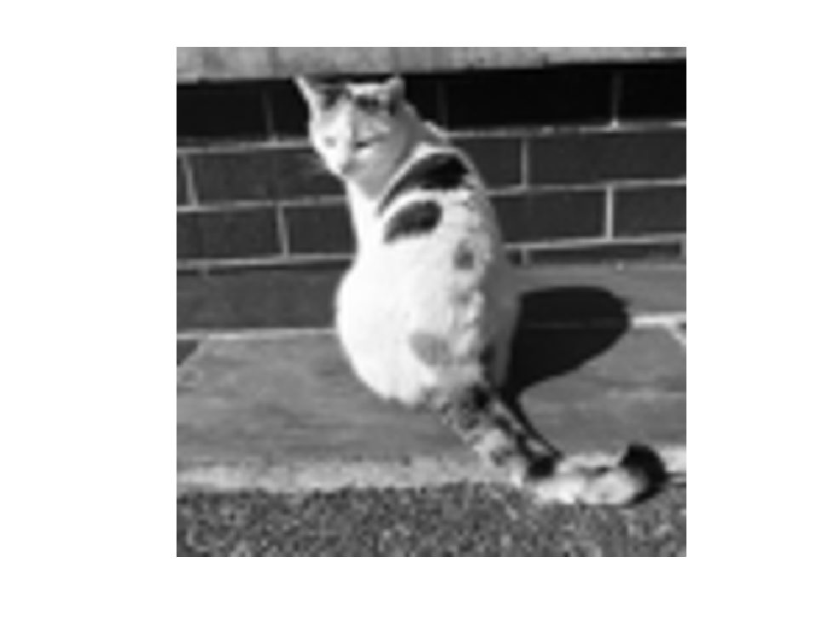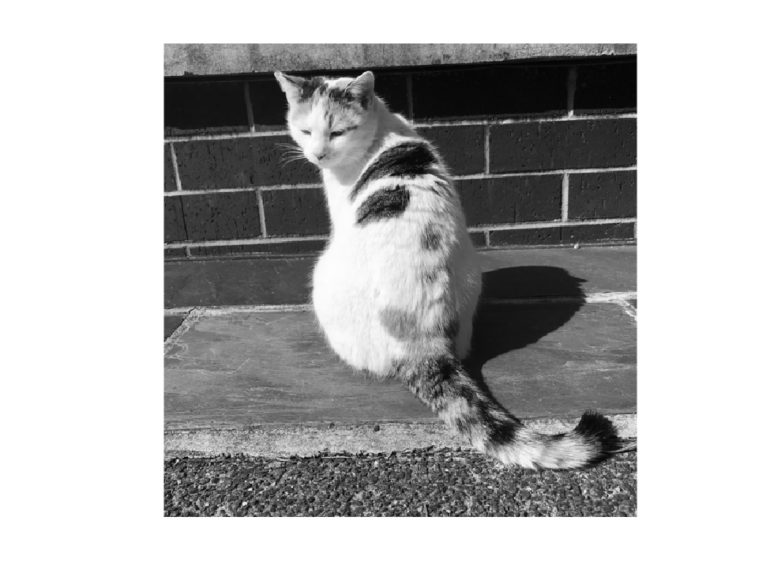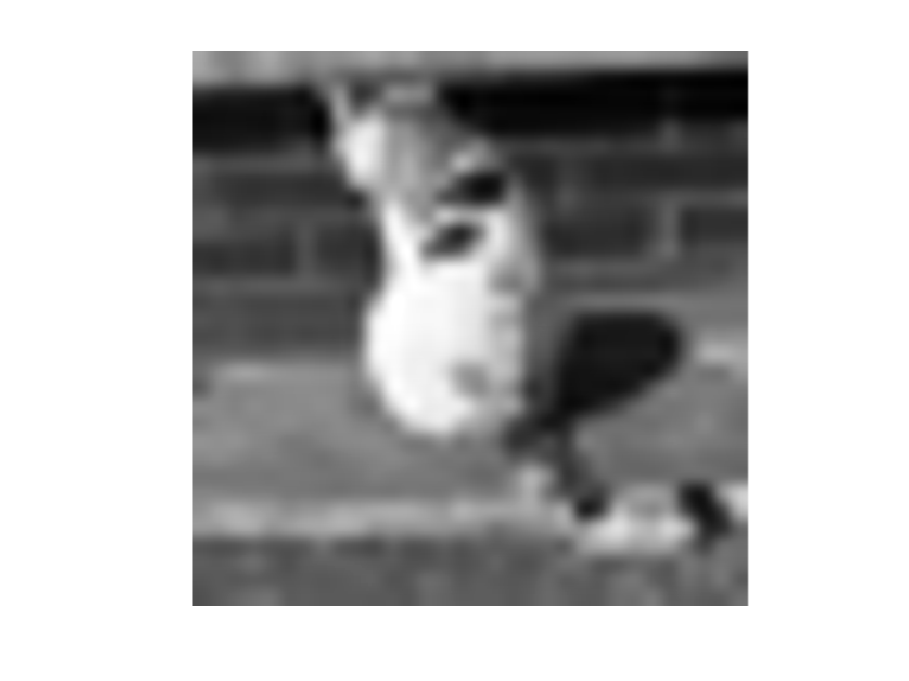

(a) (b) (c)

* + 1. Which image has the tiniest FOV?

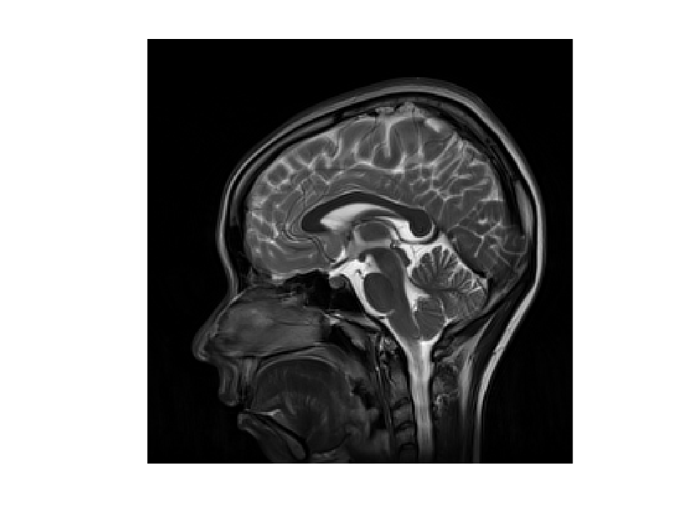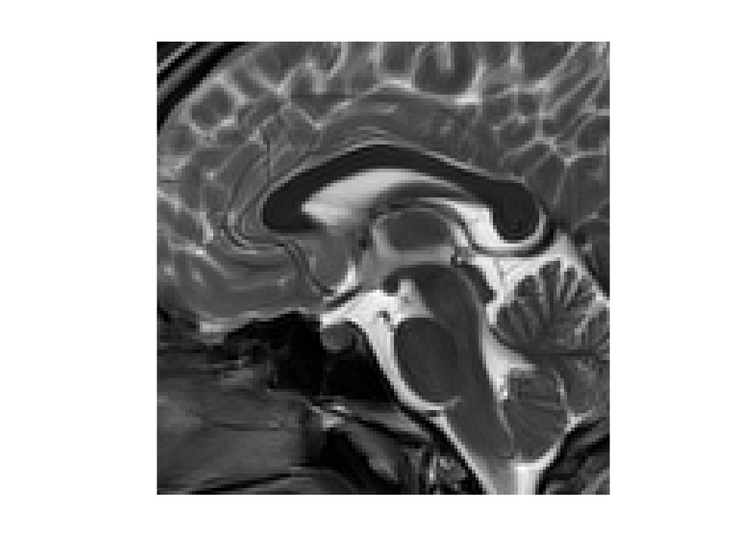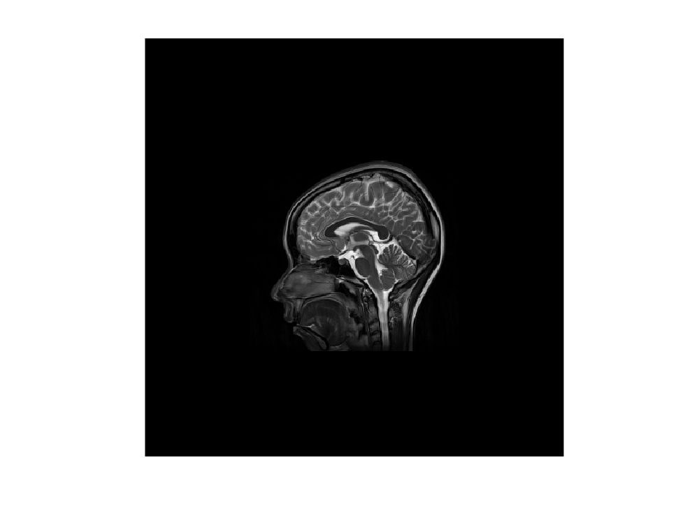

(a) (b) (c)

* + 1. Which image has the smallest matrix size?

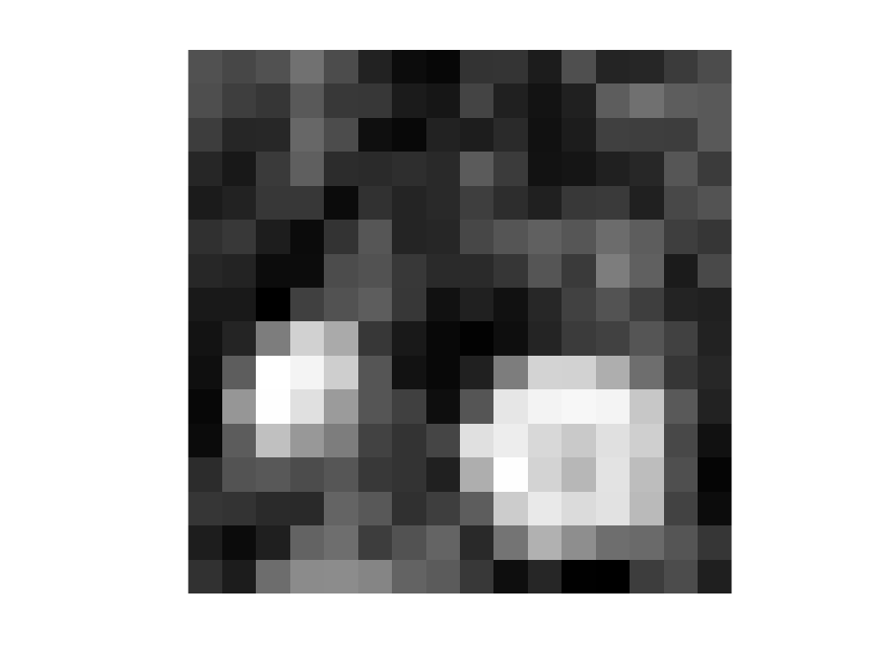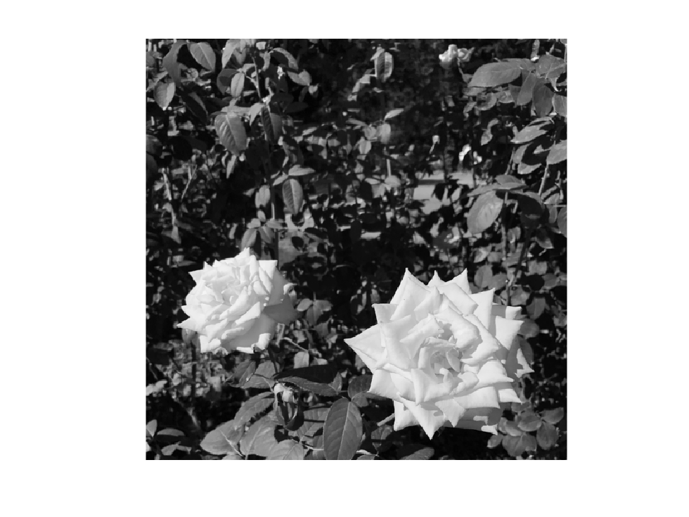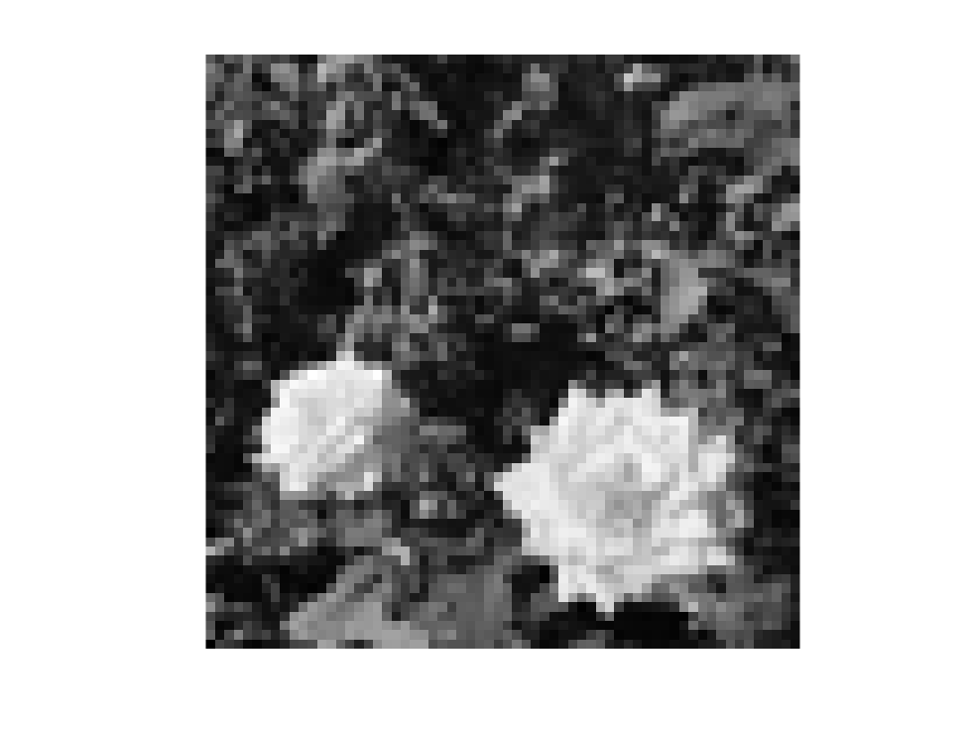

(a) (b) (c)

* 1. What is the difference between a pixel and a voxel?

i. Voxels are larger than pixels and hence contain more information

ii. Voxels are sized by volume while pixels are sized by area

iii. Voxels make up color images while pixels make up monochrome images

iv. Only MR images are made of voxels; all other medical images are made of pixels

* 1. What does zero-filling this image of a pineapple do?

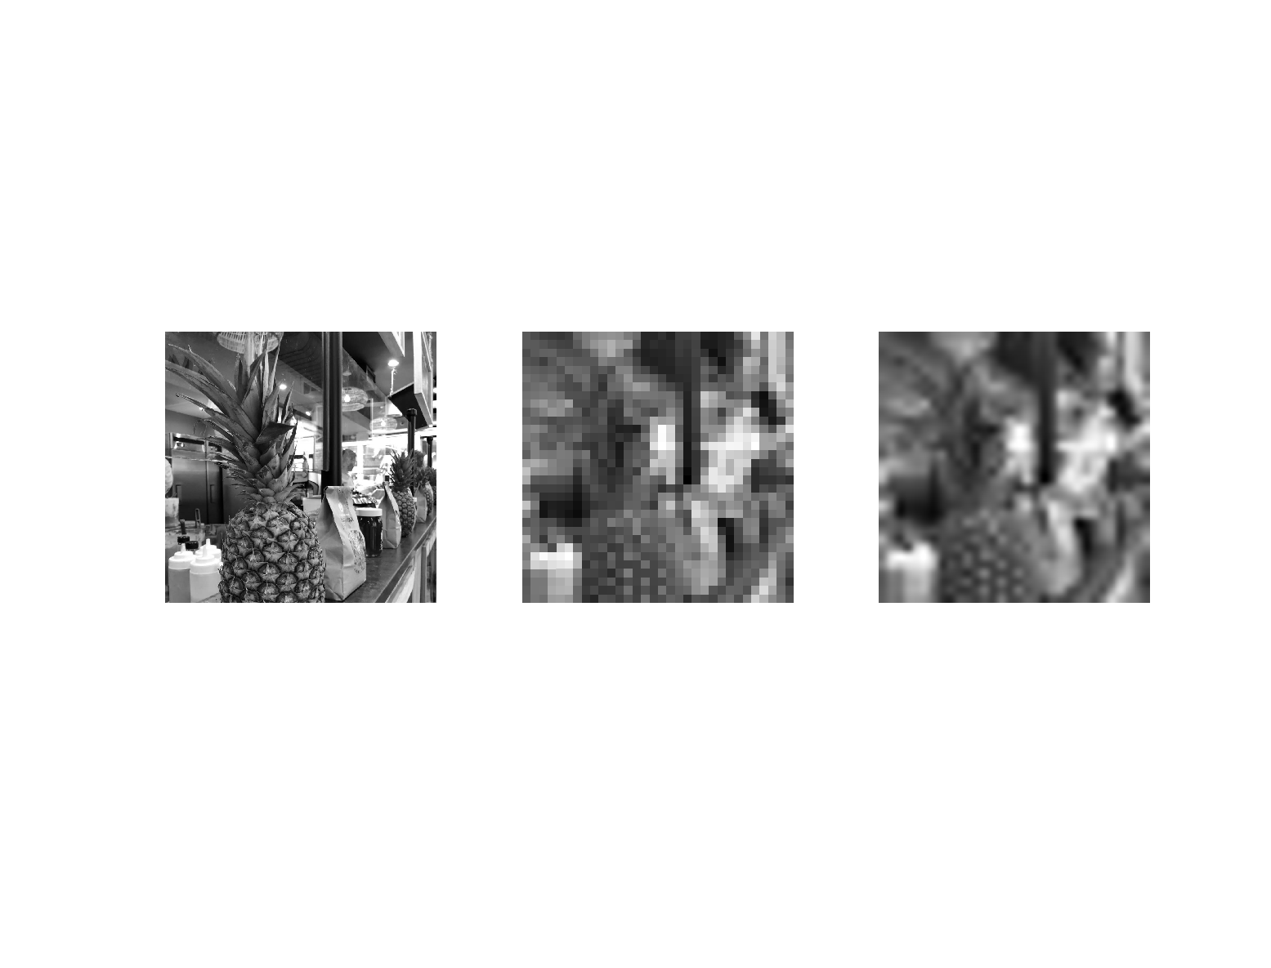

1. Original (B) Reduced matrix size (C) B, Zero Filled to original

i. It makes each pixel represent a smaller section of space

ii. It makes the fruit more delicious

iii. It sets the background values to zero and makes the pineapple stand out

iv. It improves the true resolution of the image before zero-filling